Left to right movement: most basic Left to right movement: including rotation (kinda)

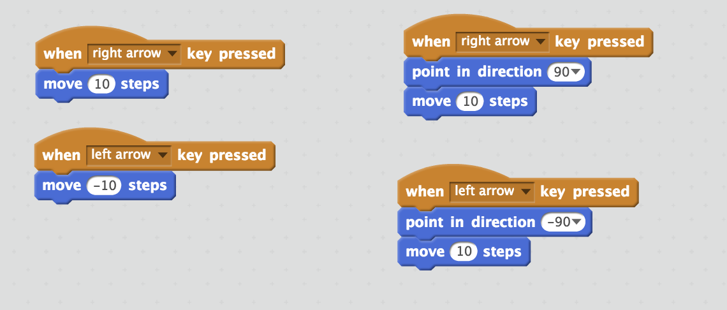

Maze Movement
Use when you need to detect barriers (like maze walls).

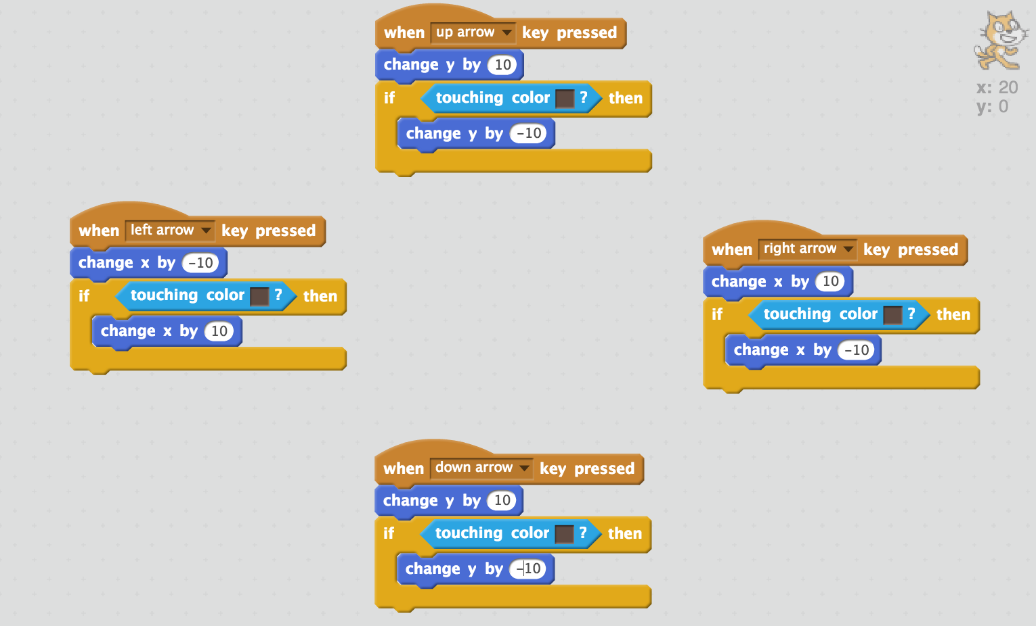

Automatic Movement: Bouncing
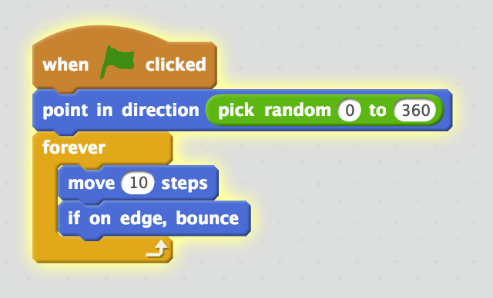

Automatic Movement: Falling or Shooting
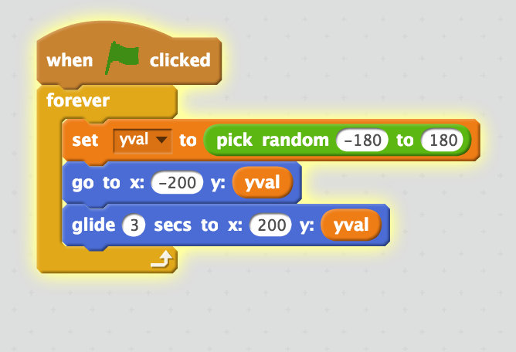

Follow the mouse pointer (erratic behavior when movement stops)
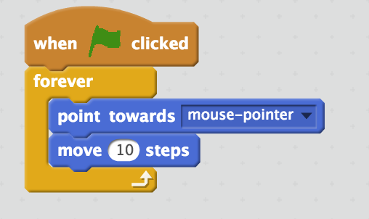

Steering with going forward and back
